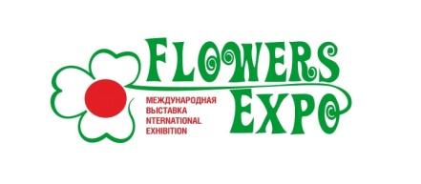
International Exhibition «FlowersExpo»

Moscow, International exhibition center «Crocus Expo»
Pavilion 1, September 12-14, 2023

To be returned to the following address:
e-mail:ez@flowers-expo.ru

APPLICATION FORM

Company name______________________________________________________

Head of the company _________________________________________________

Name of the authorized representative and cell phone________________________

__________________________________________________________________

Post address: _______________________________________________________

Country____________________________________________________________

Phone_____________________________ E–mail_________________________

Internet ____________________________________________________________

__________________________________________________________________

TOTAL: _________ sq.m exhibition space

Signature ______________________ Name ______________

Date _________________________

Payment is to be effected on the receipt of the invoice from the Organizer.

